

**The Polytechnic School**

Sutton Hall, Suite 140

6049 S Backus Mall

Mesa, AZ 85212

(480) 727-1177

Fax: (480) 727-2886

poly.engineering.asu.edu

**IFT 301 – Web Programming for Human Computer Interaction**

**Web Design Project – Project Update 2**

**Name: Brandon Trinkle**

**ASU ID: 1217455031**

**Date: 4/20/2024**

**Instructions:** You should have at least **six pages of your site and one CSS file completed** by the time you submit this assignment. Use the questions below to have a written discussion about the current progress of your web design project. After you answer the questions below, insert a screenshot of the pages you have completed so far as viewed in the browser. **Do NOT screenshot the HTML code.**

1. How do you feel your web design project is coming along?

**I feel great about my webpage. I have completed it and uploaded it to the hosting website!**

1. Since your last update, what issues have you encountered? Have you already resolved them? How? If not, how do you plan to resolve them?

**All issues have been resolved. I did not like the color scheme I picked out, so I completely revamped the website colors.**

1. Describe where you would like to use JavaScript on your website. Do you have any questions about using JavaScript?

**I used JavaScript on three different pages. I have two slideshows and a form authentication script.**

1. Your web design project is almost done. Outline what you have left and how you plan on completing it.

**I have tested everything on the ASU hosting website, I do not plan to complete any more actions.**

1. With your site almost done, has your sitemap changed? If so, revise your previous sitemap and insert it below.

**I haven’t changed the site map, I just changed the color scheme. Admittedly I am not the best designer, I don’t have a creative mind. However, I am happy with the way it looks.**

1. Insert the browser view screenshot of page #1 here.

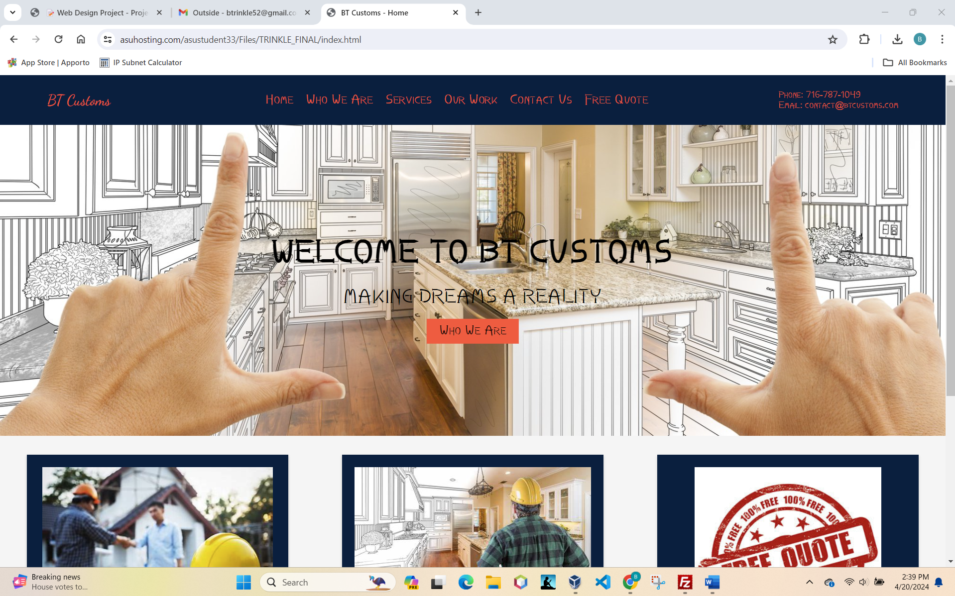

1. Insert the browser view screenshot of page #2 here.

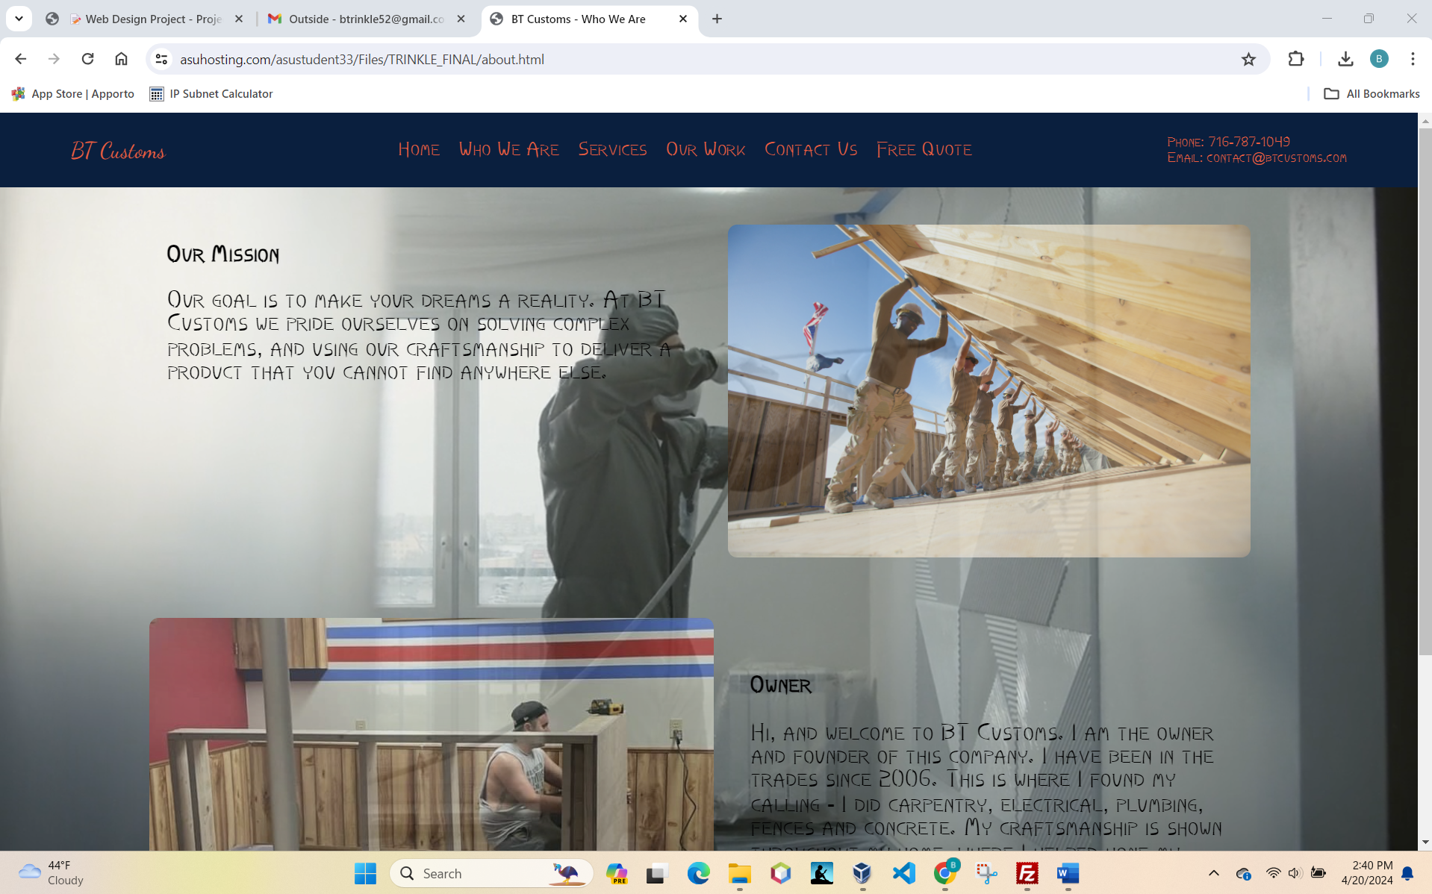

1. Insert the browser view screenshot of page #3 here.

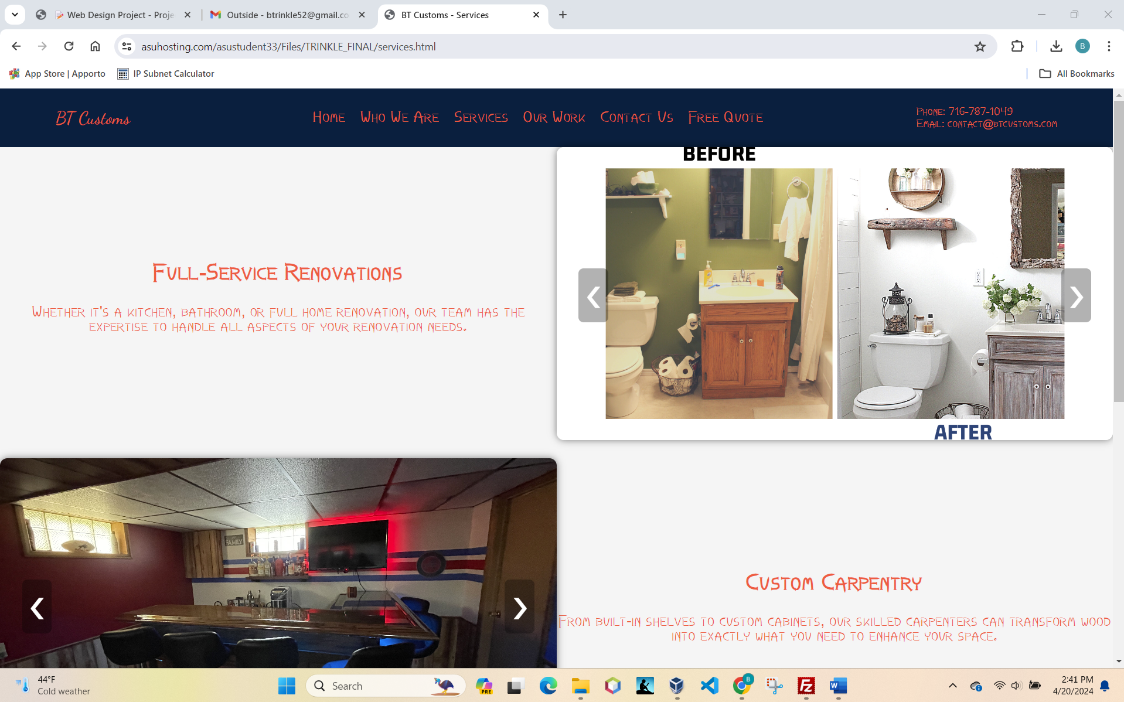

1. Insert the browser view screenshot of page #4 here.

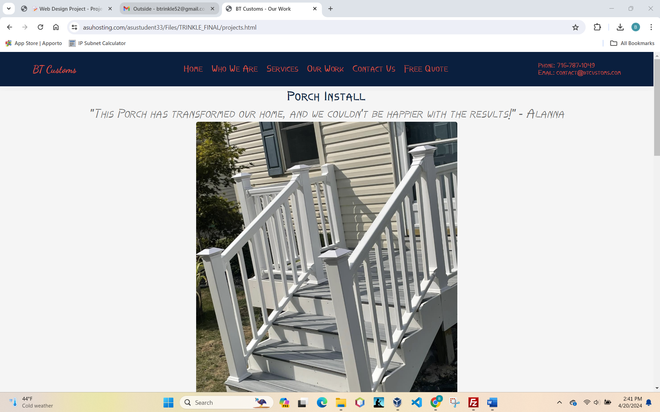

1. Insert the browser view screenshot of page #5 here.

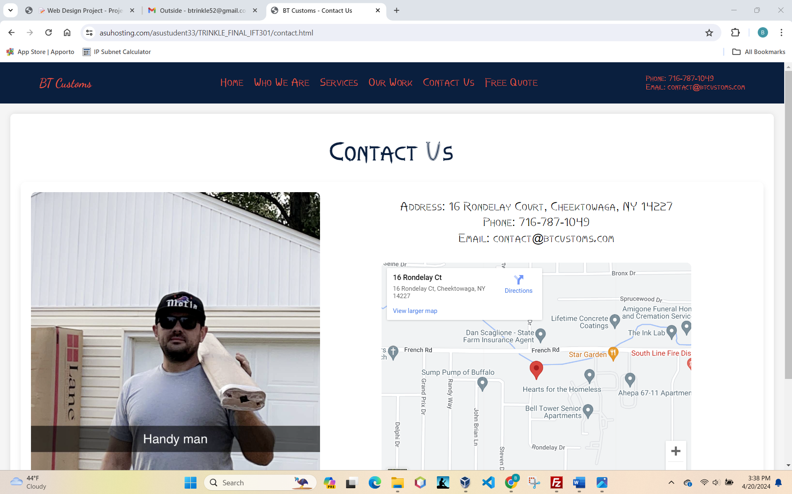

1. Insert the browser view screenshot of page #6 here.

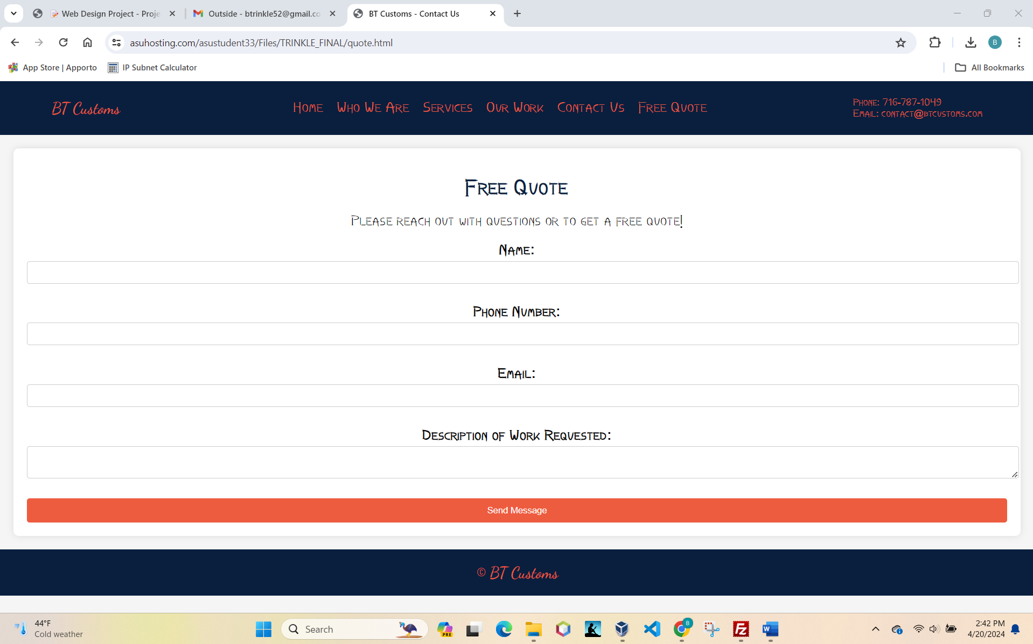

1. Copy and paste the text of your CSS file here.
2. /* General Styles */
3. body, html {
4. background-color: whitesmoke;
5. color: #000000;
6. font-family: 'Times New Roman', Times, serif, sans-serif;
7. margin: 0;
8. padding: 0;
9. font-size: 20px;
10. }
11. body {
12. background-color: whitesmoke !important;
13. }
14. /* Header Styles */
15. header {
16. align-items: center;
17. background-color: #001f3f;
18. color: #ff5733;
19. display: flex;
20. justify-content: space-between;
21. padding: 10px 5%;
22. }
23. header .logo a,
24. nav ul li a {
25. color: #ff5733;
26. text-decoration: none;
27. }
28. nav ul {
29. display: flex;
30. list-style: none;
31. }
32. nav ul li a {
33. padding: 0 10px;
34. transition: color 0.3s;
35. }
36. nav ul li a:hover {
37. color: #ff5733;
38. }
39. .contact-info {
40. color: #ff5733;
41. font-size: 14px;
42. }
43. .contact-info span {
44. display: block;
45. }
46. /* Logo Text Style */
47. .honk-logo {
48. font-family: "Dancing Script", cursive;
49. font-optical-sizing: auto;
50. font-size: 24px;
51. font-style: normal;
52. font-weight: normal;
53. }
54. /* Footer Styles */
55. footer {
56. background-color: #001f3f;
57. color: #ff5733;
58. padding: 20px 0;
59. text-align: center;
60. }
61. /* Hero Styles */
62. .hero {
63. color: #000000;
64. position: relative;
65. text-align: center;
66. }
67. .hero img {
68. display: block;
69. height: auto;
70. max-height: 500px;
71. object-fit: cover;
72. width: 100%;
73. }
74. .hero-text {
75. left: 50%;
76. position: absolute;
77. text-align: center;
78. top: 50%;
79. transform: translate(-50%, -50%);
80. }
81. .hero-text h1 {
82. font-size: 50px;
83. margin-bottom: 10px;
84. }
85. .hero-text p {
86. font-size: 30px;
87. margin-bottom: 20px;
88. }
89. /* Button Styles */
90. .btn {
91. background-color: #ff5733;
92. color: #000000;
93. display: inline-block;
94. padding: 10px 20px;
95. text-decoration: none;
96. transition: background-color 0.3s;
97. }
98. .btn:hover {
99. background-color: #d4af37;
100. }
101. /* Features Section */
102. .features {
103. display: flex;
104. flex-wrap: wrap;
105. justify-content: space-around;
106. margin: 20px 0;
107. }
108. .feature-box {
109. background-color: #001f3f;
110. box-shadow: 0 2px 4px rgba(0, 0, 0, 0.2);
111. margin: 10px;
112. overflow: hidden;
113. padding: 20px;
114. text-align: center;
115. width: 25%;
116. }
117. .feature-box img {
118. display: block;
119. height: auto;
120. margin: 0 auto;
121. max-width: 100%;
122. perspective: 1000px;
123. }
124. .feature-box h3,
125. .feature-box p {
126. color: #ff5733;
127. }
128. /* About Us Style */
129. .black-text {
130. color: #000000;
131. }
132. .photo-border {
133. border-radius: 10px;
134. transition: box-shadow 0.3s ease;
135. opacity: 0.7
136. }
137. .photo-border:hover {
138. box-shadow: 0 0 20px rgba(255, 87, 51, 0.8);
139. opacity: 1;
140. }
141. .black-text h2,
142. .black-text p {
143. color: #000000;
144. font-size: 24px;
145. }
146. .our-story-text {
147. color: #ff5733; /* Orange text */
148. font-family: 'Arial', sans-serif;
149. font-size: 16px;
150. line-height: 1.5;
151. margin-bottom: 20px;
152. text-align: justify;
153. }
154. #our-mission .container,
155. #our-story .container {
156. align-items: flex-start;
157. display: flex;
158. flex-wrap: wrap;
159. justify-content: space-between;
160. margin: 0 auto;
161. max-width: 1200px;
162. padding: 20px;
163. }
164. #our-mission .text-section,
165. #our-mission .image-section,
166. #our-story .text-section {
167. flex: 1;
168. margin: 20px;
169. }
170. #our-story .text-section {
171. padding: 20px;
172. }
173. #our-mission .image-section,
174. #our-story .image-section {
175. position: relative;
176. min-height: 200px;
177. }
178. #our-story .image-section img,
179. #our-mission .image-section img {
180. width: 100%;
181. height: auto;
182. object-fit: cover;
183. max-height: 400px;
184. border-radius: 10px;
185. }
186. /* Image Container Styles */
187. .image-container img {
188. display: block;
189. width: auto;
190. height: auto;
191. object-fit: cover;
192. transition: transform 0.3s ease;
193. opacity: 0.7;
194. }
195. /* Hover Effects */
196. .image-container:hover {
197. transform: scale(1.1);
198. opacity: 1;
199. }
200. .image-container:hover img {
201. transform: scale(1.1);
202. }
203. /* Responsive Adjustments */
204. @media (max-width: 992px) {
205. .feature-box {
206. width: 45%;
207. }
208. #our-mission .container,
209. #our-story .container {
210. flex-direction: column;
211. }
212. #our-mission .text-section,
213. #our-mission .image-section {
214. max-width: 100%;
215. margin: 10px 0;
216. }
217. #our-story .container {
218. flex-direction: column-reverse;
219. }
220. }
221. @media (max-width: 768px) {
222. .feature-box {
223. width: 100%;
224. }
225. nav ul {
226. flex-direction: column;
227. }
228. nav ul li a {
229. padding: 5px;
230. text-align: center;
231. }
232. nav ul li a:hover {
233. color: #ff5733;
234. }
235. }
236. @media (max-width: 768px) {
237. .image-container {
238. height: auto;
239. }
240. }
241. /* Video Background Styles */
242. #background-video {
243. position: fixed;
244. right: 0;
245. bottom: 0;
246. min-width: 100%;
247. min-height: 100%;
248. width: auto;
249. height: auto;
250. z-index: -1;
251. background-size: cover;
252. }
253. body, html {
254. height: 100%;
255. margin: 0;
256. }
257. body {
258. position: relative;
259. z-index: 1;
260. background: rgba(0, 0, 0, 0.5);
261. }
262. @font-face {
263. font-family: 'CustomFont';
264. src: url('Nails-DYX9.ttf') format('truetype');
265. }
266. body {
267. font-family: 'CustomFont', Arial, sans-serif;
268. }
269. /* services tab*/
270. .slideshow-container {
271. position: relative;
272. width: 50%;
273. display: inline-block;
274. overflow: visible;
275. perspective: 1000px;
276. }
277. .mySlides {
278. display: none;
279. width: 100%;
280. height: auto;
281. backface-visibility: hidden;
282. transition: transform 0.6s, opacity 0.6s ease-in-out;
283. }
284. .mySlides img {
285. width: 100%;
286. height: 400px;
287. object-fit: cover;
288. border-radius: 10px;
289. box-shadow: 0 0 10px rgba(0, 0, 0, 0.5);
290. transition: box-shadow 0.3s ease;
291. }
292. .mySlides img:hover {
293. box-shadow: 0 0 20px rgba(255, 87, 51, 0.8);
294. }
295. .image-container {
296. display: inline-block;
297. position: relative;
298. overflow: hidden;
299. border-radius: 10px;
300. transition: transform 0.3s ease, box-shadow 0.3s ease, border-color 0.3s ease;
301. width: 100%;
302. height: 250px;
303. }
304. .image-container img {
305. width: 100%;
306. height: auto;
307. object-fit: cover;
308. }
309. .image-container:hover {
310. transform: scale(1.1);
311. box-shadow: 0 0 20px rgba(255, 255, 255, 0.9);
312. border-color: rgba(255, 255, 255, 0.9);
313. }
314. .service {
315. display: flex;
316. margin-bottom: 20px;
317. justify-content: center;
318. }
319. .service-description {
320. width: 50%;
321. color: #ff5733;
322. text-align: center;
323. margin: auto;
324. }
325. .mySlides.show {
326. display: block;
327. opacity: 1;
328. }
329. .text {
330. position: absolute;
331. bottom: 0;
332. width: 100%;
333. text-align: center;
334. color: #ff5733;
335. background-color: rgba(0, 0, 0, 0.5);
336. padding: 10px 0;
337. }
338. .prev, .next {
339. position: absolute;
340. top: 50%;
341. transform: translateY(-50%);
342. color: #ffffff;
343. font-size: 24px;
344. text-decoration: none;
345. z-index: 2;
346. opacity: 1;
347. background: rgba(0, 0, 0, 0.3);
348. padding: 10px;
349. transition: background 0.3s;
350. border-radius: 7px
351. }
352. .next {
353. right: 10px;
354. }
355. .prev {
356. left: 10px;
357. }
358. .prev:hover, .next:hover {
359. background-color: rgba(0,0,0,0.9);
360. }
361. .service-description {
362. width: 50%;
363. color: #ff5733;
364. text-align: center;
365. }
366. .mySlides img {
367. width: 100%;
368. height: 400px;
369. object-fit: cover;
370. border-radius: 10px;
371. }
372. .services {
373. padding: 50px 0;
374. background-color: #f9f9f9;
375. text-align: center;
376. }
377. .services h2 {
378. margin-bottom: 30px;
379. }
380. .service-grid {
381. display: grid;
382. grid-template-columns: repeat(auto-fit, minmax(250px, 1fr));
383. gap: 20px;
384. }
385. .service-item {
386. background-color: #ffffff;
387. padding: 20px;
388. box-shadow: 0 0 10px rgba(0, 0, 0, 0.1);
389. }
390. .service-item img {
391. max-width: 100%;
392. height: auto;
393. margin-bottom: 20px;
394. }
395. .service-item h3 {
396. color: #ff5733;
397. font-size: 24px;
398. margin-bottom: 10px;
399. }
400. .service-item p {
401. color: #333333;
402. }
403. /* projects */
404. .project-image {
405. width: 40%;
406. margin: 0 auto;
407. cursor: pointer;
408. transition: transform 0.3s ease;
409. display: block;
410. text-align: center;
411. border: 4px solid transparent;
412. }
413. .project-image:hover img {
414. transform: scale(1.05);
415. }
416. .lightbox {
417. display: none;
418. position: fixed;
419. z-index: 1000;
420. left: 0;
421. top: 0;
422. width: 100%;
423. height: 100%;
424. background-color: rgba(0, 0, 0, 0.8);
425. align-items: center;
426. justify-content: center;
427. }
428. .close-btn {
429. position: absolute;
430. top: 10px;
431. right: 25px;
432. font-size: 30px;
433. font-weight: bold;
434. color: white;
435. cursor: pointer;
436. user-select: none;
437. }
438. .lightbox:hover .close-btn {
439. color: #ccc;
440. }
441. .lightbox img {
442. max-width: 90%;
443. max-height: 80%;
444. }
445. .prev, .next {
446. cursor: pointer;
447. position: absolute;
448. top: 50%;
449. transform: translateY(-50%);
450. color: white;
451. font-size: 2em;
452. user-select: none;
453. }
454. .prev { left: 30px; }
455. .next { right: 30px; }
456. .project-container {
457. display: block;
458. justify-content: space-around;
459. flex-wrap: wrap;
460. margin-bottom: 30px;
461. box-shadow: 0 8px 20px -5px rgba(0, 0, 0, 0.2);
462. margin-bottom: 30px;
463. padding-bottom: 20px;
464. text-align: center;
465. }
466. .project-container h3 {
467. font-size: 28px;
468. font-weight: bold;
469. color: #001f3f;
470. text-align: center;
471. margin: 20px 0;
472. letter-spacing: 1px;
473. }
474. .project-container h3,
475. .project-container .quote {
476. display: block;
477. margin: 10px auto;
478. }
479. .project-container .quote {
480. font-style: italic;
481. font-size: 20pt;
482. color: #666;
483. margin: 0 20px;
484. }
485. .project-image img {
486. width: 100%;
487. height: auto;
488. display: block;
489. transition: transform 0.3s ease;
490. border-radius: 5px;
491. }
492. .project-image:hover {
493. animation: borderAnimation 0.5s forwards;
494. }
495. @media (max-width: 768px) {
496. .project-image {
497. width: 45%;
498. }
499. }
500. @media (max-width: 480px) {
501. .project-container {
502. flex-direction: column;
503. }
504. .project-image {
505. width: 90%;
506. margin: 10px 0;
507. }
508. .project-container h3 {
509. margin: 10px 0;
510. }
511. }
512. @keyframes borderAnimation {
513. 0% {
514. border-color: transparent;
515. border-width: 0px;
516. }
517. 100% {
518. border-color: #ff5733;
519. border-width: 4px;
520. }
521. }
522. /* Quote Section */
523. .contact-us {
524. background-color: #ffffff;
525. padding: 20px;
526. margin: 20px;
527. border-radius: 8px;
528. box-shadow: 0 0 10px rgba(0, 0, 0, 0.1);
529. }
530. .contact-us h1 {
531. color: #001f3f;
532. }
533. .contact-us form {
534. display: flex;
535. flex-direction: column;
536. }
537. .contact-us label {
538. margin-bottom: 5px;
539. font-weight: bold;
540. }
541. .contact-us input,
542. .contact-us textarea {
543. margin-bottom: 10px;
544. padding: 8px;
545. border-radius: 4px;
546. border: 1px solid #ccc;
547. }
548. .contact-us button {
549. background-color: #ff5733;
550. color: white;
551. padding: 10px 20px;
552. border: none;
553. border-radius: 4px;
554. cursor: pointer;
555. transition: background-color 0.3s ease;
556. }
557. .contact-us button:hover {
558. background-color: #d4af37;
559. }
560. .error-message {
561. color: #ff4d4d;
562. margin: 5px 0 15px;
563. font-size: 14px;
564. }
565. input, textarea {
566. margin-bottom: 5px;
567. width: 100%;
568. padding: 8px;
569. border: 1px solid #ccc;
570. }
571. input.error, textarea.error {
572. border-color: #ff4d4d;
573. }
574. /* Contact Us Styles */
575. .contact-us {
576. padding: 20px;
577. text-align: center;
578. font-size: 24px;
579. }
580. .contact-header {
581. text-align: center;
582. margin-bottom: 20px;
583. }
584. .contact-content {
585. display: flex;
586. align-items: flex-start;
587. justify-content: space-between;
588. padding: 20px;
589. border-radius: 10px;
590. box-shadow: 0 5px 10px rgba(0, 0, 0, 0.1);
591. }
592. .contact-photo-border {
593. border-radius: 10px;
594. transition: box-shadow 0.3s ease;
595. }
596. .contact-photo {
597. flex-basis: 40%;
598. height: 550px;
599. }
600. .contact-photo img {
601. width: 100%;
602. max-height: 100%;
603. object-fit: cover;
604. border-radius: 10px;
605. }
606. .contact-photo:hover {
607. border-radius: 10px;
608. transition: box-shadow 0.3s ease;
609. box-shadow: 0 0 20px 5px #ff4d4d;
610. }
611. .contact-info-right {
612. flex-basis: 60%;
613. text-align: left;
614. }
615. .contact-details {
616. padding: 10px 20px;
617. border-radius: 10px;
618. }
619. .contact-details p {
620. font-size: 22px;
621. margin: 5px 0;
622. text-align: center;
623. }
624. .google-maps {
625. display: flex;
626. justify-content: center;
627. margin-top: 20px;
628. }
629. .google-maps iframe {
630. border-radius: 10px;
631. border: none;
632. }